SQL indexes are special lookup tables that the database search engine uses to speed up data retrieval. They are essential for enhancing the performance of queries, especially on large tables. Indexes are created on columns that are frequently used in **WHERE** clauses, **JOIN** operations, or as part of primary key and unique constraints.

**Types of Indexes :**

1. **Single-Column Index**: Created on a single column of a table.
2. **Composite Index (Multi-Column Index)**: Created on multiple columns of a table.
3. **Unique Index**: Ensures that all the values in the index are unique.
4. **Full-Text Index**: Supports full-text search capabilities.
5. **Clustered Index**: Determines the physical order of data in a table. There can be only one clustered index per table.
6. **Non-Clustered Index**: Does not alter the physical order of the table and there can be multiple non-clustered indexes on a single table.

**Example Usage**

Let's consider a table **Employee** with the following columns: **id**, **name**, **department**, and **salary**.

**1. Creating a Single-Column Index**

You might want to create an index on the **name** column to speed up searches based on employee names.

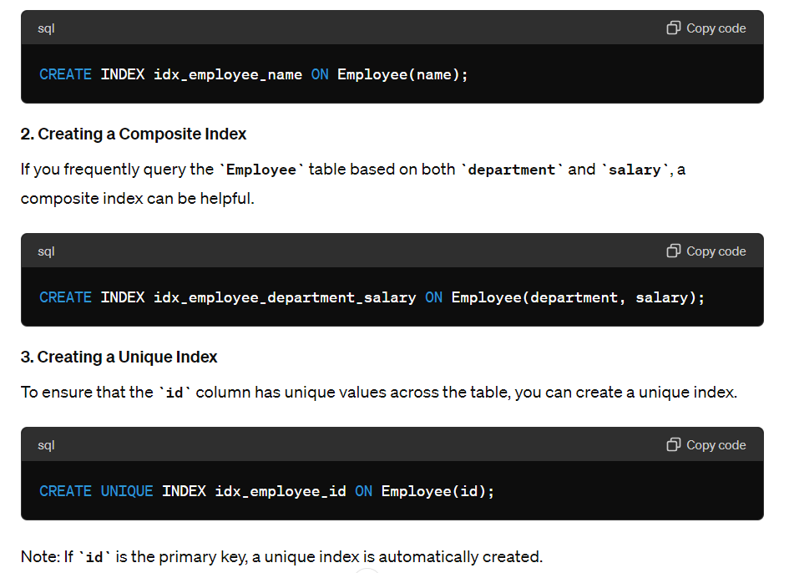

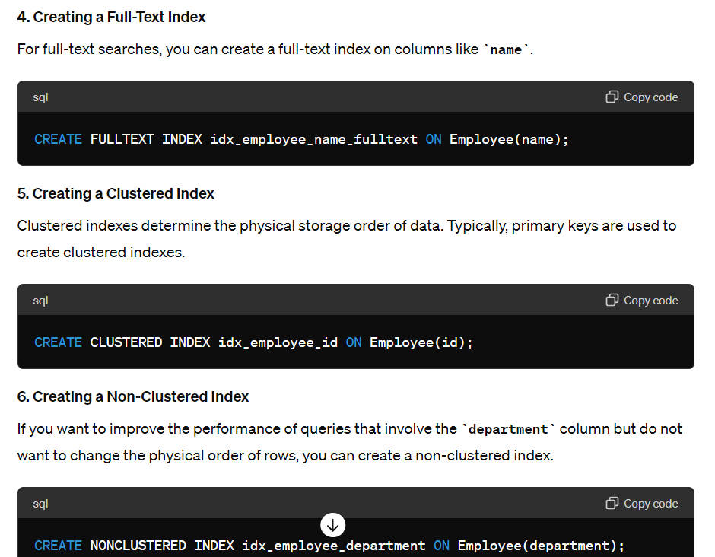

**Query Performance**

Let's see how these indexes improve query performance. Without indexes, searching for employees in a specific department might be slow on large tables:

With the non-clustered index on **department**, this query will be much faster, as the database engine can quickly locate the rows without scanning the entire table.



**Dropping an Index**

If an index is no longer needed, it can be dropped to save space and improve write performance:



**Conclusion**

Indexes are crucial for optimizing query performance in SQL databases. By creating appropriate indexes based on query patterns, you can significantly reduce the time it takes to retrieve data. However, indexes come with trade-offs, such as increased storage requirements and potential performance overhead for insert, update, and delete operations. It's essential to balance these factors when designing your database schema.